The third MCI group Project client meeting will be held in Zoom at 2:00pm on Tuesday 23th March 2021

Agenda

**Chair:** Emily Yingyao Lu

**Secretary:** Portia On Ki Ng

**1 1 Meeting Objectives**

* Feedback on Prototype
* Confirm app structure & tab names
* Feedback on Pitch slides
* Confirm requirements & Milestone 1

**2 Presentation**

MindSpace Prototype v1.0

<https://www.figma.com/file/rzIzKXMMsuvZwdmDKJ2dyJ/MindSpace?node-id=0%3A1>

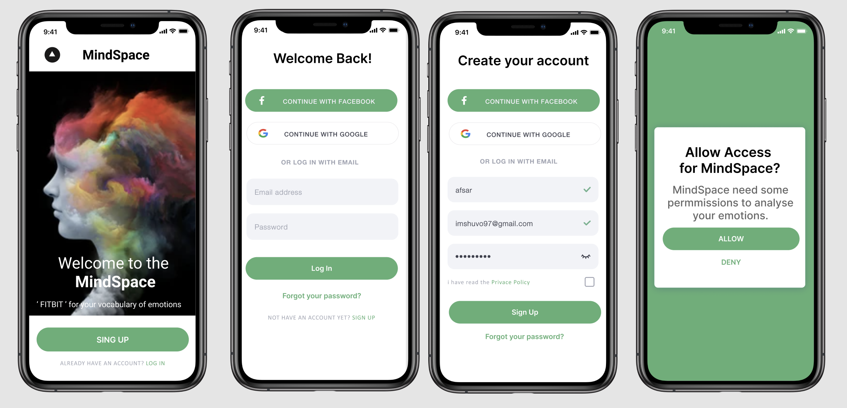

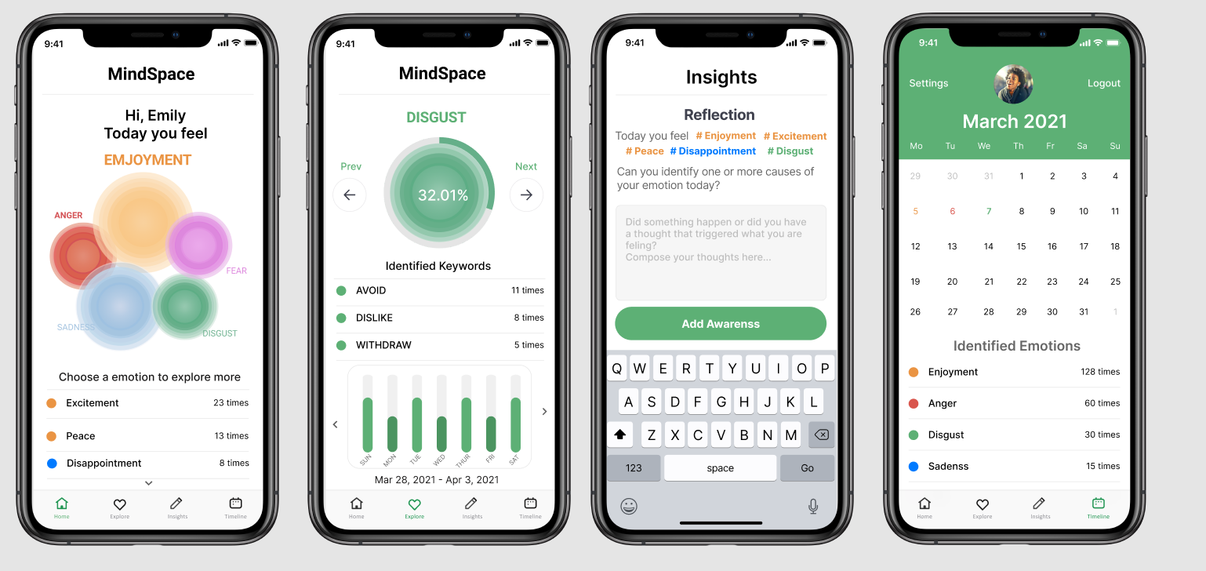

**3 Requirements Elicitation**

3.1 Feedback on the modified Prototype

3.1.1 Confirm app structure & tab names

3.2 Feedback on the presentation slides

Pitch Slides

<https://app.pitch.com/app/presentation/ce4e2a10-466e-4cab-afd9-e82c6c9a8884/a957a585-8ac0-48c9-b496-b1727b1cbb94>

3.2.1 Setting up the context: The importance of emotional awareness

3.2.2 What is MindSpace?

3.2.3 Why is it important to use MindSpace?

3.2.4 Feasibility and Summary

3.3 Confirm requirements & Milestone 1

**4 Other Issues**

**Note:** Next meeting will be held on 30th March 2021